**E-Project**: Movie booking system

Movie Booking System:

|  |  |  |
| --- | --- | --- |
| **Supervisor.** | Miss Ambreen | |
| **Batch.** | 2212F1 | |
| **Group.** | - | |
| **Serial No.** | **Enrollment Number** | **Student Name** |
| 1. | Student1422580 | AROOSHA NAFEES |
| 2. | Student1428001 | AREESHA KAINAT |
| 3. | Student1428000 | ALIYAN KHAN |

1

E-Project: Movie booking system

# Introduction :

The thirst for learning, upgrading technical skills and applying the concepts in real life environment at a fast pace is what the industry demands from IT professionals today. However busy work schedules, far-flung locations, unavailability of convenient time-slots pose as major barriers when it comes to applying the concepts into realism. And hence the need to look out for alternative means of implementation in the form of laddered approach.

The above truly pose as constraints especially for our students too! With their busy schedules, it is indeed difficult for our students to keep up with the genuine and constant need for integrated application which can be seen live especially so in the field of IT education where technology can change on the spur of a moment. *Well, technology does come to our rescue at such times!!*

Keeping the above in mind and in tune with our constant endeavour to use Technology in our training model, we at Aptech have thought of revolutionizing the way our students learn and implement the concepts using tools themselves by providing a *live and synchronous eProject learning environment!*

**So what is this eProject?**

eProject is a step by step learning environment that closely simulates the classroom and Lab based learning environment into actual implementation. It is a project implementation at your fingertips!! An electronic, live juncture on the machine that allows you to

* Practice step by step i.e. laddered approach.
* Build a larger more robust application.
* Usage of certain utilities in applications designed by user.
* Single program to unified code leading to a complete application.
* Learn implementation of concepts in a phased manner.
* Enhance skills and add value.
* Work on real life projects.
* Give a real life scenario and help to create applications more complicated and useful.
* Mentoring through email support.

The students at the centre are expected to complete this eProject and send complete documentation with source code to eProjects Team

Looking forward to a positive response from your end!!

2

# Objectives of the project

* The Objective of this program is to give a sample project to work on real life projects. These applications help you build a larger more robust application.
* The objective is not to teach you concepts but to provide you with a real life scenario and help you create applications using the tools.
* You can revise them before you start with the project.
* It is very essential that a student has a clear understanding of the subject.
* Kindly get back to eProjects Team in case of any doubts regarding the application or its objectives.

3

E-Project: Movie booking website

# PROBLEM STATEMENT

Problem statement is attached separately in a file “**Movie Booking System**”

**Standards plan:**

Every code block must have comments.

The logic of the program needs to be explained. Proper documentation should be maintained.

Complete Project Report along with synopsis, code and documentation should be prepared.

**Documentation:**

No project is complete without documentation. In fact, it is one of the most important activities during the development of a project. The documentation of an ideal project will be in the form of a project report comprising of the following documents:

* Certificate of Completion.
* Table of Contents.
* Problem Definition.
* Customer Requirement Specification.
* Project Plan.
* E-R Diagrams.
* Algorithms.
* GUI Standards Document.
* Interface Design Document.
* Task Sheet.
* Project Review and Monitoring Report.
* Unit Testing Check List.
* Final Check List.

4

E-Project: Movie booking website

# Hardware/ Software Requirements

**Hardware**

* A minimum computer system that will help you access all the tools in the courses is a Pentium 166 or better
* 128 Megabytes of RAM or better

**Operating System**

* LINUX / Windows 2000 Server (or higher if possible)

**Software**

* PHP
* MySQL
* PERL
* Apache

5

E-Project: Movie booking website

# AGGREGATED SITEMAP

**HOME PAGE**

VERIFY.PHP

RESERVED UR SEATS

(booking .php)

**BOOK A SEATS**

CONTACT

(3. contact-us.php)

Booking SEATS

(booking .php)

(1.Index.php)

TEAM

SCHEDULE

(2. schedule .php)

# SITEMAP

SHOW,TIMINGS,DETAIL

Schedule

Team

About us

MAP,CONTACT

Contact

Verify.php

Reserved your seats

(index.html)

HOME

# Main Layout

1. 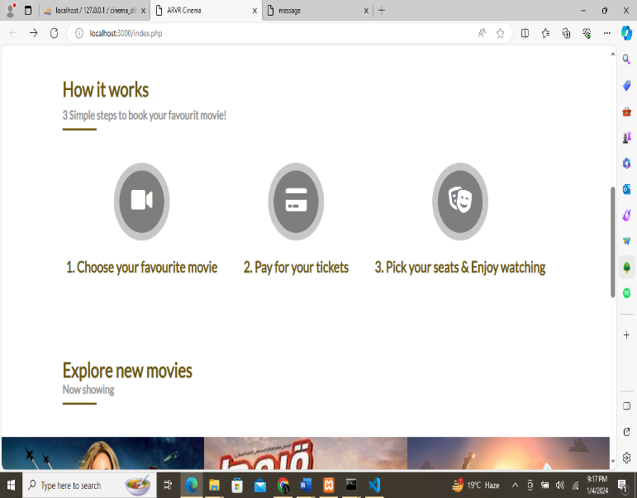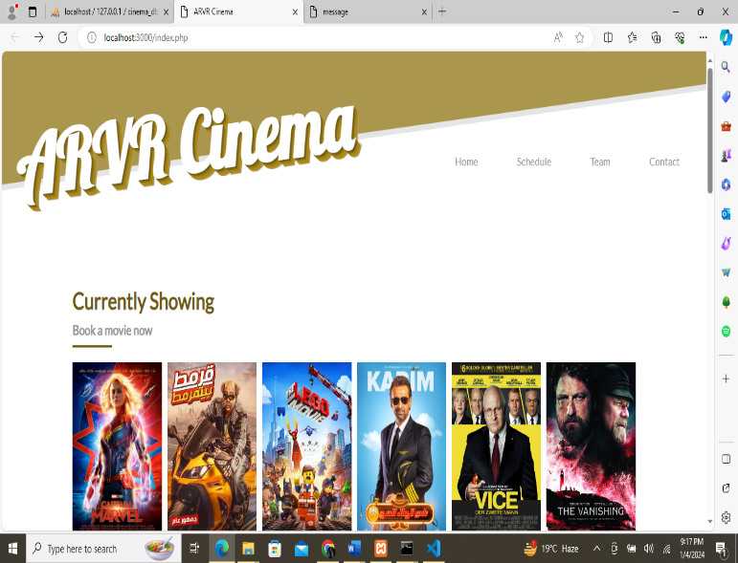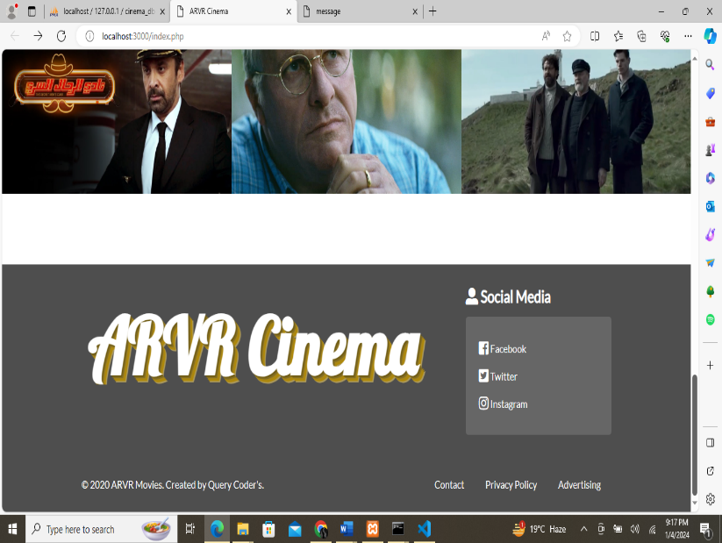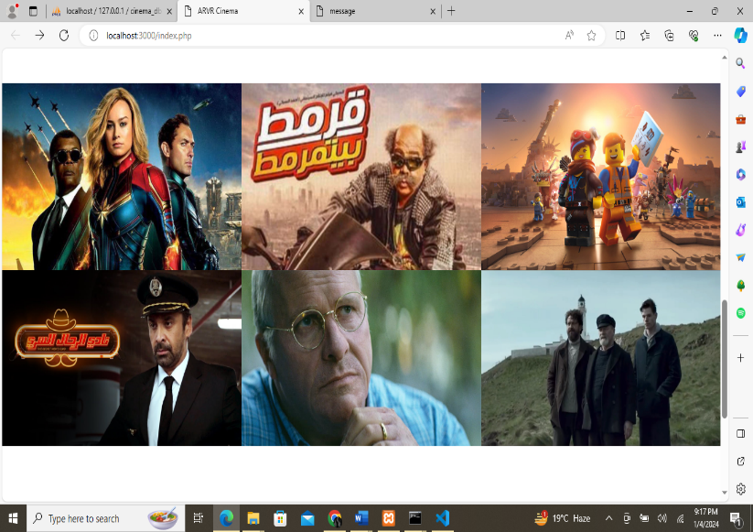**HOME PAGE**
2. **SCHEDULE**

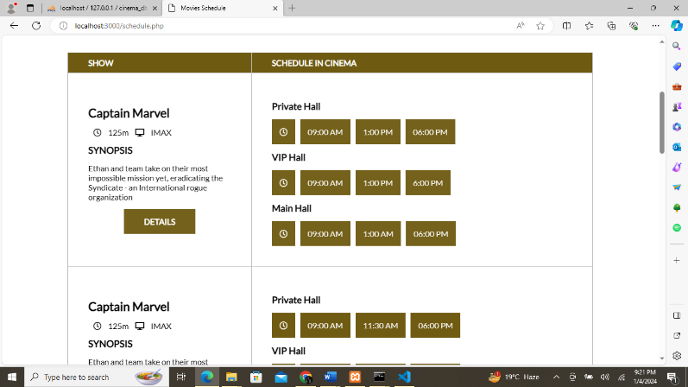

# 

# 

# 

3. **CONTACT**

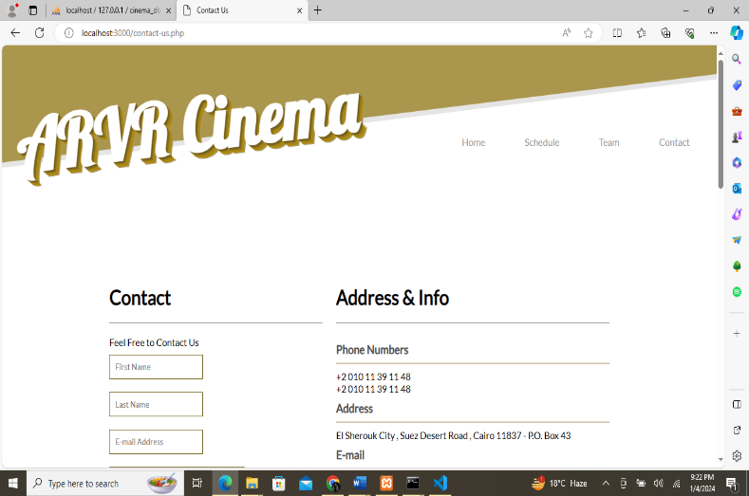

# 

# 

# 

4. **BOOKING**

# 

# 

# 

# TASK SHEET REVIEW

|  |  |  |  |  |  |  |
| --- | --- | --- | --- | --- | --- | --- |
| Project Ref. No.: eP/Advertisement Portal Management  System/01 | | Project title | Date of Preparation of Activity Plan | | | |
| No | Task | Movie B Booking S System | Actual | Actual | Team-mate | Status |
| Start Date | Days | Names |
| 1 | Build Home | 7/12/23 | 2 | Student-1  Student-2  Student-3 | Complete |
| Page |
| 2 | Build Schedule Page | 10/12/23 | 2 | Complete |
| 3 |  | 12/12/23 | 1 | Complete |
| Build Contact Page |
|  |
| 4 | Build booking page | 14/12/23 | 2 | Complete |
| 5 | Build admin panel | 17/12/23 | 3 | Complete |
| 6 | Build User panel | 21/12/23 | 2 | Complete |
|  |
|  |
|  |

**Thank You For Reading The Documentation.**